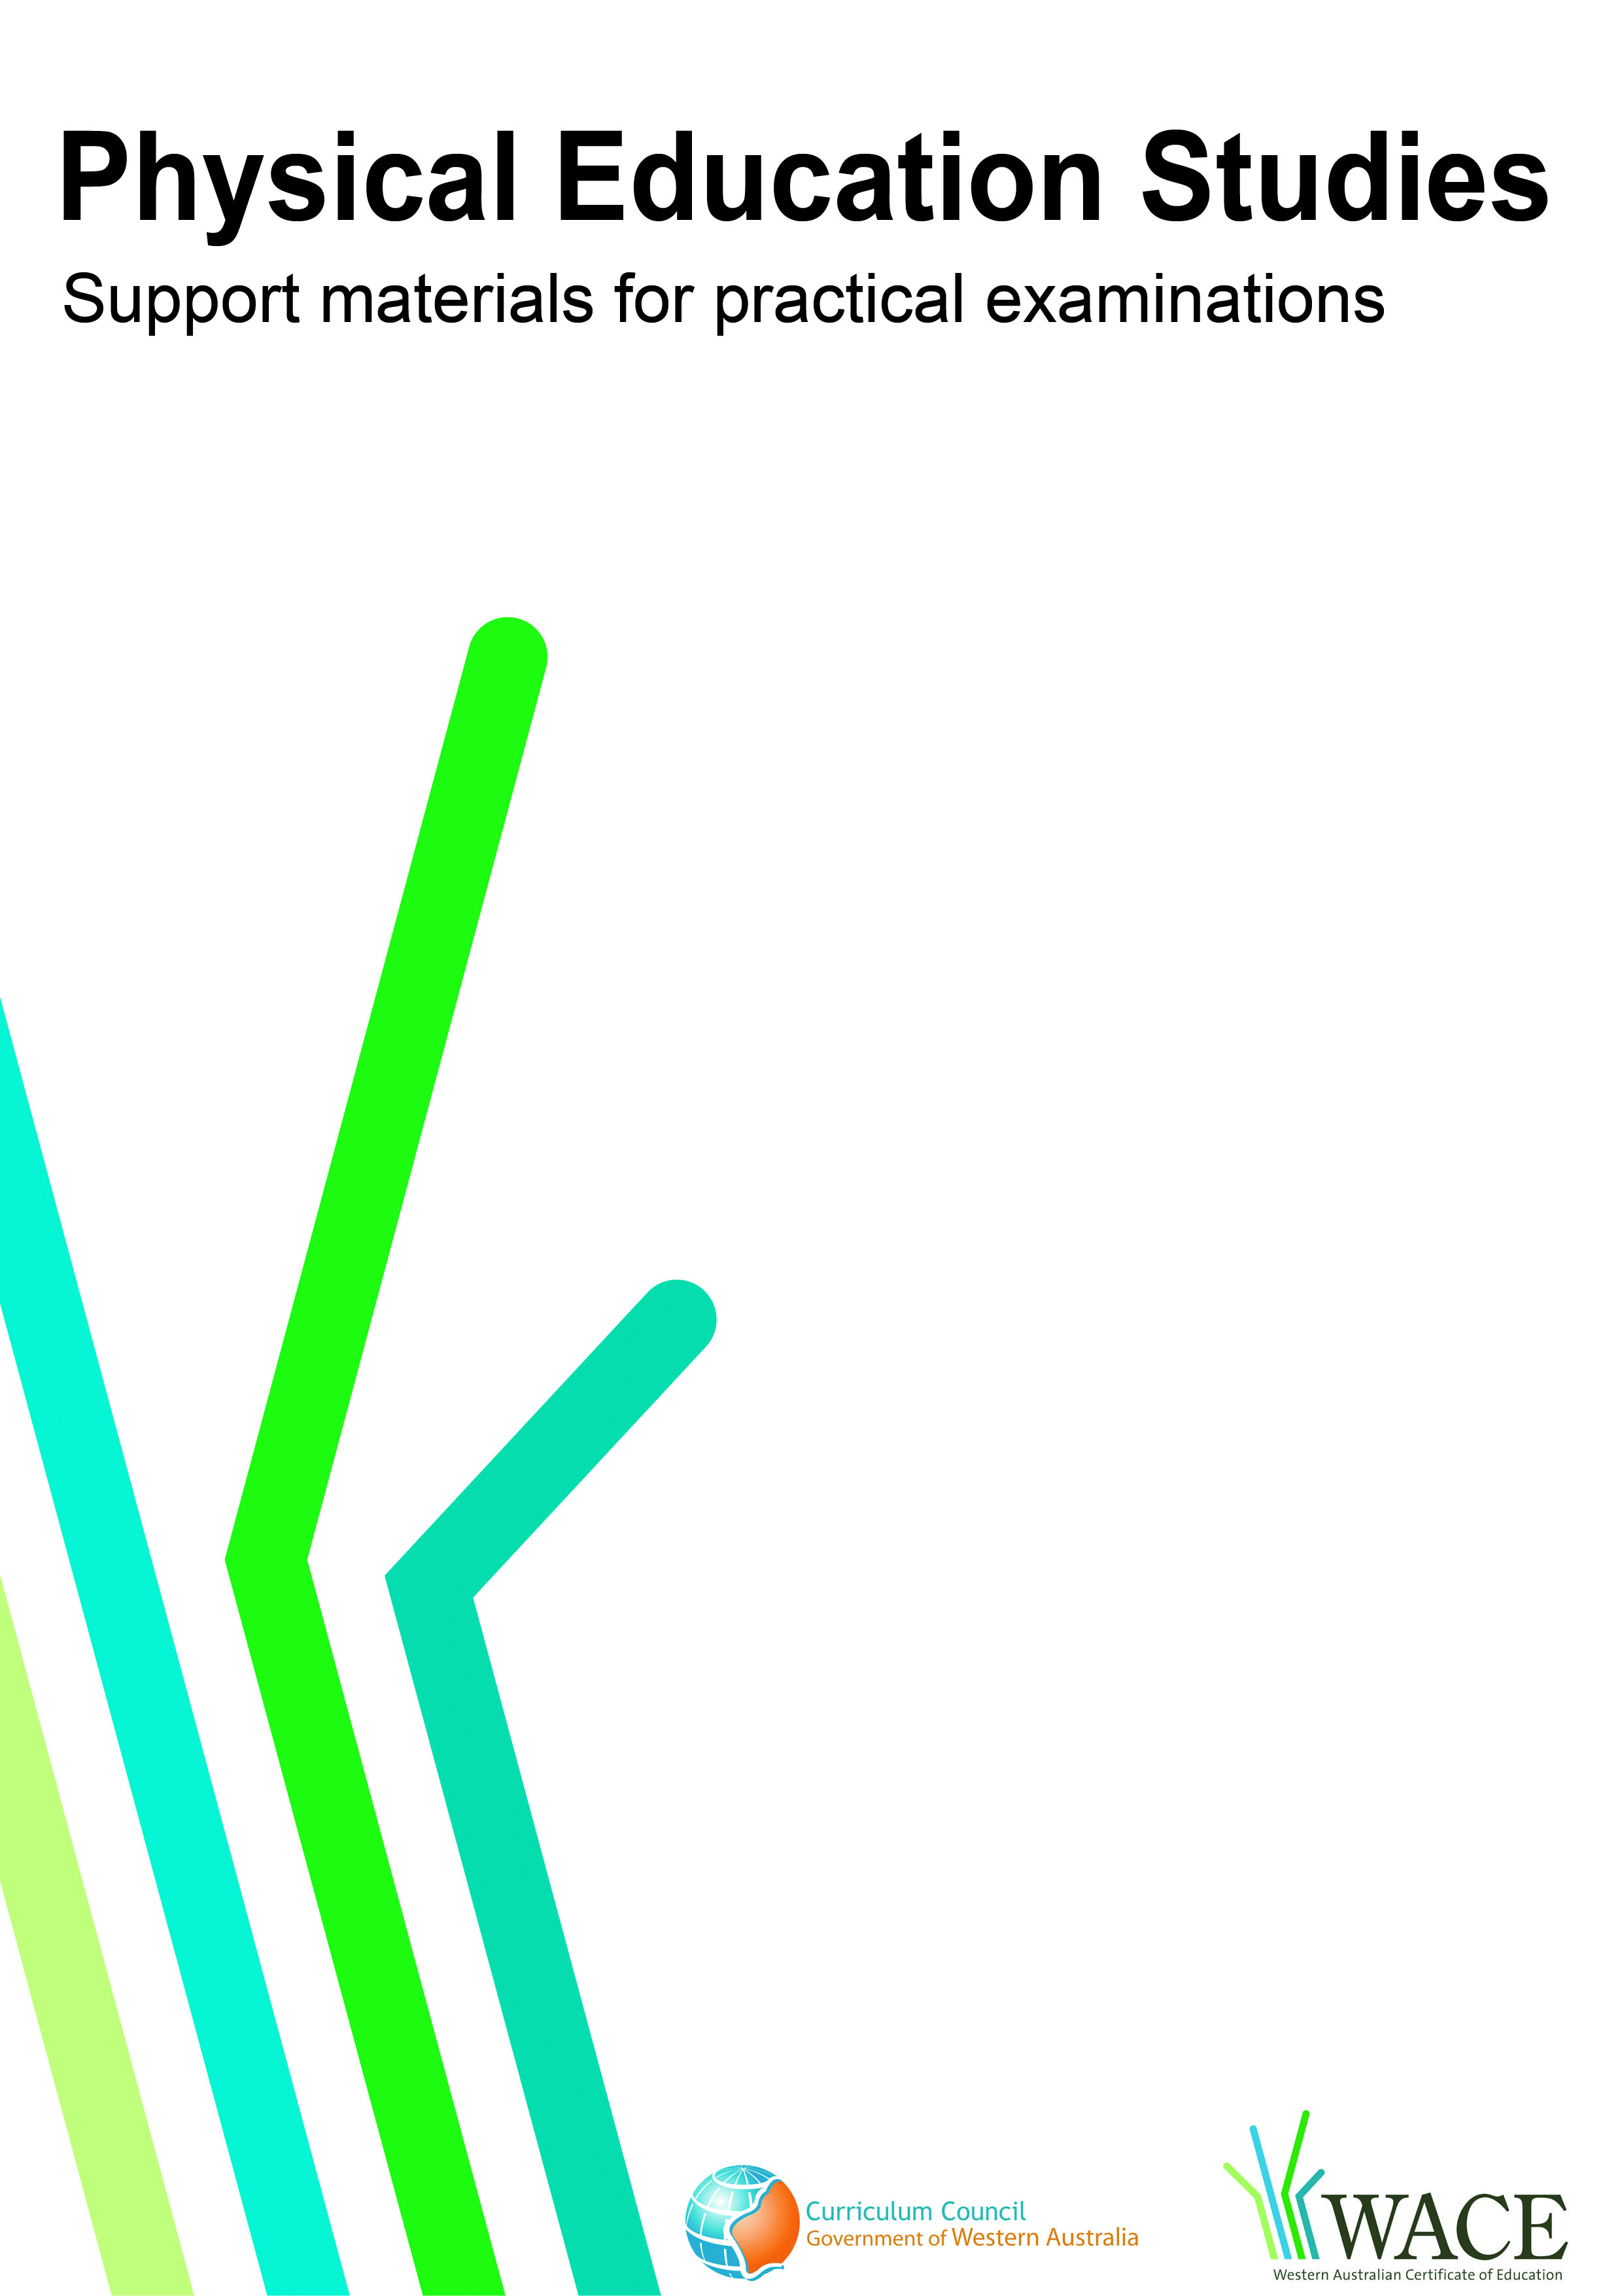

Soccer

© Curriculum Council, 2011
This document—apart from any third party copyright material contained in it—may be freely copied, or communicated on an intranet, for non-commercial purposes by educational institutions, provided that it is not changed in any way and that the Curriculum Council is acknowledged as the copyright owner.
Copying or communication for any other purpose can be done only within the terms of the Copyright Act or by permission of the Curriculum Council.
Copying or communication of any third party copyright material contained in this document can be done only within the terms of the Copyright Act or by permission of the copyright owners.
Version 5

Introduction
Volleyball
The purpose of these materials is to support teachers and candidates in preparation for the Physical Education Studies practical examination.

Skills set for soccer
These materials outline the examinable skills set for soccer. Five (5) of the skills, selected by the examination panel, will be examined and these will be communicated to the candidates at the commencement of the examination.

Observation points
Observation points are provided for each skill in the skills set. They are provided for the purpose of teaching and coaching and are designed to assist examination candidates in their personal skill development.

Examination drills
The examination will contain a number of drills through which the selected skills will be assessed. These materials outline a number of drills indicative of the types of drills in which the candidates will participate during the examination and may form part of a teaching program.

Tactical framework
In the conditioned performance section of the examination, candidates will participate in a modified competitive situation, which will be based on some of the tactical problems in soccer. The tactical problems for the examination are outlined in the tactical framework and will be selected by the examination panel. The skills that provide the basis for the solutions to these tactical problems are also included in the framework.

In the conditioned performance section of the soccer examination, students will be assessed on the execution of skills, use of space, positioning and decision making that effectively solve the tactical problems presented by the modified competitive situation.

Specialist skills
Contained within this document are a number of skills that have been identified as having a degree of specialisation. They are skills that some students may choose to focus on. These skills are included within this document as they may form part of a teaching program; however, they will not be included in the Physical Education Studies practical examination.

CONTENTS | PAGE NUMBER
Soccer skills set | 5
Skills set and observation points | 6
Soccer drills | 11
Drill descriptions | 12
Tactical framework | 34

Skill number | Name of skill | Page number
1 | Heading (Attack and Defence) | 6
2 | Short Pass | 6
3 | Long Lofted Pass | 7
4 | Throw In | 7
5 | Dribbling | 8
6 | Shooting | 8
7 | Control – Low Ball | 9
8 | Control – High Ball | 9
9 | Volleying | 10
10 | First Touch Juggling | 10
11 | Specialist skill – Goalkeeping (not examined externally) | 10

1. HEADING (attack and defence)
Preparation | Execution | Completion
- Balance in anticipation on the balls of feet  - Hips and knees are flexed  - Shoulders are square to the path of the ball  - Eyes track the ball  - Torso maintains upright position, not leaning forward or backwards | - Moves towards the ball (If necessary)  - Knees extend as the ball approaches to initiate jump  - Arms lift up to assist in getting height, generating power and balance  - Body arches backward from the torso  - Head reaches upward and toward the ball (neck extended) and in the direction where the ball is intended to travel  - Timing of the header – the head ‘meets’ the approaching ball during the forward momentum before the head and torso becomes linear  - Ball contacts on the middle section of the forehead | - Fluency – the preparation and execution completed in sequence  - Upper body continues in direction of headed ball  - Flight and direction successfully clears ball from danger zone
2. SHORT PASS
Preparation | Execution | Completion
- Player standing balanced in anticipation on the balls of the feet (not flat footed)  - The ball is approached in fluid motion, knees slightly bent with body fluent and balanced  - The supporting foot is placed next to and level with the centre of the ball with knee slightly bent for balance  - Supporting foot facing towards the intended target | - Supporting leg slightly flexed to provide balance  - Head is down and over the ball  - Kicking leg swings forward towards the centre of the ball  - As the foot meets the ball the foot is turned to the outside, parallel to the ground with ankle locked (firm not floppy)  - Instep makes contact with the ball, striking through the centre of the ball  - Timing of the pass – the foot ‘meets’ the ball central to the body – not reaching for the ball | - Kicking foot follows through in the direction of the ball  - The body still balanced (not leaning back)  - Ball moves along the ground (not bouncing along the ground or in the air) in a forward rolling direction

3. LONG LOFTED PASS
Preparation | Execution | Completion
- Ball is positioned between the kicker and the target  - Approach to the ball made at an angle of approx 30° (Not straight at the ball)  - Ball is approached in a fluid and balanced motion  - As the ball is approached the supporting foot reaches toward and is placed next to and level with the centre of the ball. The knee is slightly bent for balance  - Supporting foot faces towards the intended target  - Kicking leg then moves toward the ball with knee slightly bent | - Supporting leg slightly flexed to provide balance  - Head over the ball looking towards the intended target  - Kicking leg swings forward towards the bottom part of the ball  - As the foot meets the ball the foot is turned to the outside, parallel to the ground with ankle locked (firm not floppy)  - Instep makes contact with the ball, striking through the centre of the ball  - Timing of the pass – the kicking foot ‘meets’ the ball central to the body – not reaching for the ball | - Kicking foot follows through in the direction of the kick  - The body still balanced (not leaning back)  - Ball moves toward the target in the air (not bobbling along the ground) ideally reaching approximately 2 metres above the ground at its highest point (this demonstrates the ability to play the ‘lofted’ pass over the opposition players – technical execution)  - Fluency – the preparation and execution completed in sequence
4. THROW IN
Preparation | Execution | Completion
- Body is balanced on the balls of the feet (not flat footed)  - Hands to be placed slightly behind the ball (Not directly on each side of the ball)  - Ball is drawn behind the head  - Head to be upright with eyes facing towards the target (not hunched over)  - Shoulders to be square to the intended target | - Knees are flexed to provide propulsion  - Back extends with arms extended behind the head  - Flexion of upper body causes a slinging motion of arms  - Ball is released just after it moves past the back of the head | - Upper body follows through in the direction of the throw  - Appropriate flight and direction is used to allow team mate to control the ball easily

5. DRIBBLING
Preparation | Execution | Completion
- Ball is positioned close and central to the body  - Dribbling knee is positioned up and over the ball  - Body is balanced  - Head is positioned over the ball  - Body facing the defender  - Ball is kept central to the body | - Dribbling foot pushes the ball forward in a controlled manner  - Knee is over the ball as it is touched forward  - Ball is always kept within control-distance of the foot  - Use both inside and outside of the foot to move the ball forward  - Eyes are kept up to assess further play options (Eyes not fixed only on the ball)  - Player simultaneously dribbles and scans the field | - Player controls the ball and is able to utilise further options
6. SHOOTING
Preparation | Execution | Completion
- Ball is positioned between (or level with) the kicker and the target  - Ball is approached at a slight angle  - Ideally approach is to be no longer than three metres | - Supporting leg is positioned next to the ball and is slightly flexed to provide balance  - Head is down over the ball  - Knee and body are positioned slightly over the ball  - Arms are out to maintain balance  - Shooting leg swings forward with knee flexed, foot extended, ankle firm  - Contact is made with the top of the foot (laces) moving through the ball | - Shooting foot swings ‘through’ the ball along with body weight  - Appropriate power is applied to the ball and is consistent with position of goalkeeper  - Ball hits the intended target

7. CONTROL – LOW BALL
Preparation | Execution | Completion
- Body is balanced in anticipation on the balls of the feet  - Hips and knees are flexed  - Body moved into position behind the path of the approaching ball  - Eyes are kept on the ball | - Receiving foot is parallel to the ground and slightly raised  - Supporting foot is positioned alongside the ball with knee flexed and arms out to maintain balance  - Head is over the ball  - The centre of the ball is ‘cushioned’ using the middle of the inside of foot | - Ball is in a position to be used effectively after it has been controlled
8. CONTROL – HIGH BALL
Preparation | Execution | Completion
- Body is balanced in anticipation on the balls of the feet  - Hips and knees are flexed  - Body moved into position behind the path of the approaching ball  - Eyes are kept on the ball  - Arms are out to maintain balance  - Back begins extension in preparation for contact with the ball | - Knees are flexed and back is arched to allow ‘cushioning’ of the ball by receiving body part (thigh, knee, chest or head)  - Receiving body part relaxes upon impact to ‘cushion’ the ball  - Ball is able to be passed to target within a further two touches | - Ball is controlled and brought to ground as quickly as possible and in a position to be used effectively

9. VOLLEYING
Preparation | Execution | Completion
- Body is balanced in anticipation on the balls of the feet  - Hips and knees are flexed  - Shoulders are square to the path of the ball  - Eyes track the ball to the foot  - Torso maintains upright position, not leaning forward or backwards | - Move is toward the ball (if necessary)  - Supporting foot is ‘planted’ before impact with the ball  - Timing of the volley– the foot ‘meets’ the approaching ball with a firm locked ankle  - Ball contact is made with the instep and/or top of the foot  - Ball is directed to the target eg chest area  - Body is not leaning back | - Fluency – the preparation and execution completed in sequence  - Flight and direction of the ball is consistent with player intentions eg shooting for goal
10. FIRST TOUCH JUGGLING
Preparation | Execution | Completion
- Body is balanced on the balls of the feet (not flat footed)  - Hips and knees are flexed  - Eyes are kept on the ball  - Arms are out to maintain balance | - Ball is kept off the ground  With the foot  - Contact is made with the top of the foot  - Knee flexes and extends to contact under the ball with some backspin created  With the thigh  - Contact is made with the thigh just above the knee with no spin  With the head  - Contact is made with the upper area of the forehead with no spin | - Ball is kept in control  - Player anticipates and prepares for next option
11. SPECIALIST SKILL: GOALKEEPING (not examined externally)
Preparation | Execution | Completion
- Body is balanced in anticipation on the balls of the feet  - Hips and knees are flexed  - Hands positioned level with the hip  - Eyes tracking the ball | - Player moves toward the ball (if necessary)  - Timing of catching the ball– the hands meet the approaching ball at the highest point  - Ball contact made with ‘soft (cushioned) hands’ positioned in a ‘W’shape with thumbs up the centre behind the ball | - Fluency – the preparation and execution completed in sequence  - Flight and direction of ball is consistent with player intentions when throwing to a team mate

Drill number |  | Page number
1 | Short pass | 12
2 | Short pass | 13
3 | Control low ball and short pass | 14
4 | Passing and receiving over longer distance | 15
5 | Long, high (lofted) passing, control (foot, thigh or chest) | 16
6 | First touch juggling | 17
7 | Volleying | 19
8 | Throw-in and control of low and high balls | 20
9 | Dribbling | 21
10 | Heading | 23
11 | Shooting, control – low ball (basic shooting) | 24
12 | Shooting, control – low ball | 25
13 | Receive with inside of the back foot (both directions) | 26
14 | Control, dribbling, passing 1 v1 | 28
15 | 3 v 1 | 29
16 | Crossing and Specialist skill: Goalkeeper Catching  (not examined externally) | 30
17 | Specialist skill: Goalkeeping – collapse dive  (not examined externally) | 31
18 | Specialist Skill: Goalkeeping – throwing  (not examined externally) | 32

These drills are indicative of the types of drills in which the candidates will participate during the examination and may form part of a teaching program.

Drill 1: Short pass
X₁

1.5m

X₂

Key
X = player
O = feeder
= marker
----- = ball movement
→ = player movement

Drill description
- X₁ and X₂ pass the ball back and forth with the inside of their feet maintaining the 1.5m distance.
- One-touch passing.

Variations
- X₁ left foot to X₂ right foot.
- X₁ right foot to X₂ left foot.
- X₁ left foot to X₂ left foot.
- X₁ right foot to X₂ right foot.

Drill 2: Short pass

1.5m
0.5m
X₁
X₂
Diag. 1
X₁
X₂
Diag. 2
0.5m
X₁
X₂
Diag. 4
0.5m
X₁
X₂
Diag. 3
0.5m

Key

X = player
O = feeder
= marker
----- = ball movement
→ = player movement

Drill description (Player 1 left foot to Player 2 right foot – diag. 1)
1. Ball to be played within the 0.5m area next to the cone, ball to not touch the marker, playing the ball to the correct side and away from defender (marker).
2. One touch only and ball has to travel the full 1.5m distance (weight of pass).

Variations
- Repeat with Player 1 right foot to Player 2 left foot – diag. 2.
- Repeat with Player 1 left foot to Player 2 left foot – diag. 3.
- Repeat with Player 1 right foot to Player 2 right foot – diag. 4.

Drill 3: Control low ball and short pass

X₂
1.5m
X₁

Key

X = player
O = feeder
= marker
----- = ball movement
→ = player movement

Drill description
      - Two touches only for each player.
      - X₁ receives the pass from X₂ and takes the ball with the inside of the right foot sideways and plays the ball to X₂ with the inside of the left foot.
      - X₂ then receives the pass with the inside of the right foot, taking the ball across past the cone and plays it to X₁ with the inside of the left foot.
      - Continue – clockwise (10 circulations).
      - Repeat above going anti-clockwise i.e. using the inside of the other foot.

Drill 4: Passing and receiving over longer distance

12m

X₁
X₂
2m

3m

Key

X = player
O = feeder
= marker
----- = ball movement
→ = player movement

Drill description
- Players X₁ and X₂ pass the ball back and forth through the markers using the inside of their feet to both pass and receive.
- Each player must have at least two touches each time they manage the ball.
- The aim is to receive with the inside of the foot using the first touch (the ball must remain within the 3m grid) before passing back to their partner with an inside of the foot pass.

Variation
- Players control the ball with the inside of one foot and play the ball back with the inside of the opposite foot.

Drill 5: Long, high (lofted) passing, control (foot, thigh or chest)

20m

X₂
X₁
10m

10m
Mannequin placed in the middle

Key

X = player
O = feeder
= marker
----- = ball movement
→ = player movement

Drill description
- Players X₁ and X₂ pass the ball back and forth over the mannequin placed in the middle of the ‘valley’ using the instep of the foot to deliver a long, lofted pass to their partner.
- The ball must land inside their partner’s 10m x 10m grid.
- Each player may receive / control the ball, using the feet, thigh, chest or head, (any legal part of the body) either on the full or on the bounce as the delivery requires and have at least two touches each time they manage the ball. The ball backspins in flight.
- The aim is to receive /control with the first touch and passing with the second, although extra touches are permissible.
- The ball must remain within the 10m grid before passing back.

Variation
- Players execute the pass with both left and right feet.

Drill 6: First touch juggling

Diag.1 Diag.2

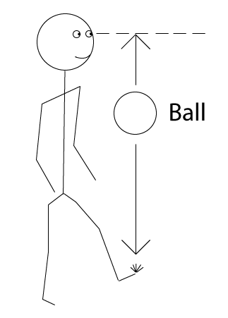

X₁

10m

Diag.3 Diag.4

X₁
X₂
X
X
X
X
6m
6m
6m
6m

Key | X = player
 | O = feeder
 | = marker
 | ----- = ball movement
 | → = player movement

Drill description (diagram 1)
- Keep the ball off the ground (45sec–1min).
- Start with right foot only then left foot only (45sec–1min).
- Repeat with right knee only and left knee only (45sec–1min).
- Repeat with right foot–right knee and left foot–left knee combinations.
- Head (30sec).

continued over

Variation 1 (diagram 2)
- Right-foot only – keep the ball up with the ball coming off the foot – ball level with the player’s eyes (eye height):
- 45sec–1min
- Left-foot only – same as above
- Right-foot – right knee combination – eye height
- Left-foot – left knee combination – eye height.

Variation 2 (diagram 3)
- Players X₁ and X₂ start within a 10m x 10m grid with a ball at their feet. Players ‘work’ at the same time and therefore need to react to each other:
- Each player uses their foot to commence a juggling sequence of between 16 and 24 touches which involves the use of left and right foot, left and right thigh, chest and head and demonstrates ‘comfortable’ performance
- After each sequence is completed, players should start another commencing with their opposite foot
- Each sequence does not need to be identical, but each should demonstrate all elements as a minimum standard.

Variation 3 (diagram 4)
- Pairs of players are each situated in a 6m x 6m grid separated by a 6m x 6m area:
- Each player must have between two and four touches each time they play the ball
- Both players in the square must play the ball each time it enters their square before it is returned to the other pair. The ball can be passed to the other pair by foot or head
- The ball may bounce once only when it arrives in the square and once again when it is transferred to the other player
- The exercise restarts when one player flicks the ball up with the feet – not using the hands.

Drill 7: Volleying
1.5m
Δ X₁
Δ X₂

Key

X = player
O = feeder
= marker
----- = ball movement
→ = player movement

Drill description
- Player X₁ throws an underarm pass to X₂, who volleys the ball back to X₁ using the inside of the foot.
- The ball must be played into the target area (chest region).
- The players alternate between left and right feet for a total of 20 volleys (i.e. 10 right, 10 left).
- The skill is then performed by the other player (X₂ throwing to X₁).

Variations
- Drill is performed using the top of the foot.
- Drill is performed using the outside of the foot.

Drill 8: Throw-in and control of low and high ball

X₁
X₂
6m
3m
3m

Key

X = player
O = feeder
= marker
----- = ball movement
→ = player movement

Drill description
- Player X₁ throws the ball 10 times to their partner X₂. Use the imaginary back line of the grid for the throw-in.
- The throw must reach their partner above the ground and with a downward loop.
- The throwing player must demonstrate the correct throwing technique.
- The receiving player must demonstrate the correct use of the feet, thigh, chest or head (or any legal body part) to receive and get the ball under control within their 3m x 3m grid and passes back.
- X₂ then picks up the ball and throws it back to X₁ (as per point 3 above), who then receives and gets the ball under control (as per point 4 above).

Drill 9: Dribbling
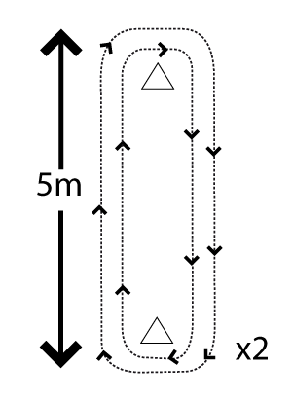
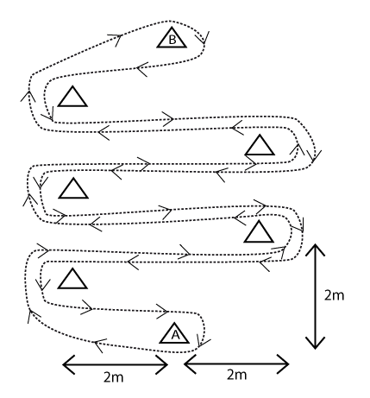
X₁
X₂
Diag. 1
X₁
Diag. 2

b
Diag. 4
Diag. 3
w
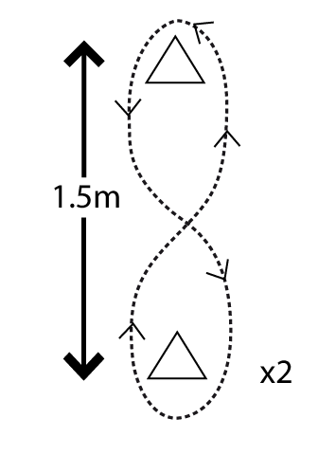
z

5m

y

X
x

a
5m
Key
X = player
O = feeder
= marker
----- = ball movement
→ = player movement

Drill description (diagram 1)
- Players X₁ and X₂ dribble the ball clockwise around the cones. Four circulations each time:
  - with little touches using any part of their feet (their own choice)
  - inside of the left foot only
  - outside of the right foot only.
- Players perform the same drill in an anti-clockwise direction:
  - with little touches using any part of their feet (their own choice)
  - inside of the right foot only
  - outside of the left foot only.
- Ball to be under control at all times, with little touches.
continued over
Variation 1 (diagram 2)
- Player X₁ dribbles the ball around the corner in a zigzag pattern. Around each cone to the top and back (cone A to B):
  - little touches using any part of their feet (their own choice)
  - left foot only
  - right foot only
  - inside of the foot only
  - outside of the foot only.

Variation 2 (diagram 3)
- Player X₁ dribbles the ball (in a figure 8 pattern) around and between the cones. Four figure 8s each time:
- with little touches using any part of their feet (their own choice)
- left foot only
- right foot only
- inside of the foot only
- outside of the foot only.
Ball to be under control at all times, and away from the cones.

Variation 3 (diagram 4)
- Player X₁ starts with the ball behind cone (a). Dribble the ball to cone (b) in and out and through the 30 cones placed unevenly within a 5-metre square. Dribble around cone (b) and back to (a):
- using any part of their feet
- left foot only
- right foot only
- inside of foot only
- outside of foot only.
Variation – to dribble the ball in a zigzag fashion on any surface with either foot.

Drill 10: Heading
5m
X₁
X₂
5m
3m
1m

b
b

a
a

Key
X = player
O = feeder
= marker
----- = ball movement
→ = player movement

Drill description
- Players X₁ and X₂ are situated in 4m x 3m grids, 5m apart and work alternately. 10 repetitions each, then change.
Defensive header
- Each player to ‘serve’ the ball with an underarm throw in any manner that enables their partner to head the ball with an upward trajectory, which in turn enables the thrower to catch the ball (ideally above the head) whilst situated in the grid.
Attacking header
- Each player will ‘serve’ the ball with an underarm throw that enables their partner to head the ball with a downward trajectory in between the target markers (a) and (b) in their partner’s grid.
- The service and the execution must be completed from within their own grid.
Variation
- Jumping to head the ball.

Drill 11: Shooting, control – low ball (basic shooting)

X₂
X₁
x
y
X₃
X₄
1.5m
1.5m

Key
X = player
O = feeder
= marker
----- = ball movement
→ = player movement

Drill description
- Player X₁ plays a pass to X₂ positioned inside the D on top of the 18-yard box.
- Player X₂ controls the ball within the D then shoots to either (x) or (y) target.
- Player X₃ then plays to X₄ etc:
- Players to choose which target to aim for (x) or (y)
- Players given a target they must hit
- Right-foot shot only
- Left-foot shot only
- Players can only shoot within D at the top of the penalty area.

Drill 12: Shooting, control – low ball
X₂
x
y
X₁
X₃
X₄
15m
18yds
15m
1.5m
1.5m

(a)
(b)

Key
X = player
O = feeder
= marker
----- = ball movement
→ = player movement

Drill description
- Player X₁ plays a pass to X₂, who plays a first-time pass back to X₁.
- Player X₁ controls the ball on the run and dribbles the ball to the edge of the penalty area [markers (a) and (b)].
- When player X₁ reaches the top of the 18-yard box, the player shoots to either (x) or (y) target.
- Player X₃ then plays to X₂ (players alternate each go):
- Players to choose which target to aim for (x) or (y)
- Players given a target they must hit
- Right-foot shot only
- Left-foot shot only
- Players cannot dribble past the edge of the penalty area [markers (a) and (b)].

Variation
- If a goalkeeper is in the assessment group, they can attempt to save the ball.

Drill 13: Control low ball: Receive with inside of the back foot (both directions)

b
a
X₃
14m
14m

Diag. 1

X₂
X₄

X₁
X₅

Diag. 2
(b) ∆ ∆
2m
(a) ∆ ∆
2m
X₁
X₅
X₄ Δ
X₂
(x)
∆
7m
7m
7m

continued over

Key | X = player
 | O = feeder
 | = marker
 | ----- = ball movement
 | → = player movement

Drill description (Diagram 1)
  - Player X₁ plays a pass to X₂ and follows the pass to take X₂’s place at marker (a) (anti-clockwise).
  - Player X₂ receives the ball with one touch and plays the ball to player X₃ with the next touch and follows the pass to marker (b) then X₃ to X₄ to X_{5.}
  - Players receive the ball with the inside of the back foot (right foot) and play the next pass with the right foot.
  - Then clockwise. Players then receive the ball with the inside of the back foot (left foot) and plays the pass with the right foot.

Variations
- Back to anti-clockwise (Diagram 1):
- receive the ball with the inside of the back foot (right foot) and play the next pass with the right foot
- receive the ball with the inside of the left foot (across the body) and play with the left foot
Clockwise
- receive the ball with the inside of the back foot (left foot) and play with the right foot
- as above, this time inside of right foot and play with the left foot.
- Player X₁ plays a pass along the ground to X₂ and follows the pass to marker (x) (anti-clockwise) (Diagram 2).
- Player X₂ receives the ball with the back foot (right foot) and moves the ball away from the marker (defender) and with the next touch plays a pass to X₃ with the inside of the left foot and follows the pass to take player X₃‘s place.
- Player X₃ receives the ball (after it has passed through the target) with the inside of the right foot and plays the ball to X₄ with the inside of the left foot, then follows the pass.
- Player X₄ receives with inside of right foot and plays the ball through the target (with the next touch) with the inside of the left foot.
- After five rotations, the players then perform the same drill, but in a clockwise direction using the inside of the other foot to receive and pass
- Must have two touches only, not hit the markers and play through the target.
Drill 14: Control, dribbling and passing, 1 v 1

20m
2m
C
2m
D
2m
B
2m
A
20m
X₈
X₇
X₆
X₅
X₁
X₂
X₃
X₄

Key
X = player
O = feeder
= marker
----- = ball movement
→ = player movement

Drill description
  - Player X₁ plays the ball to X_{5.} Player X₁ then becomes a defender and X₅ an attacker (1 v 1).
  - X₅ to take on X₁ to try and pass or run the ball into target A or B. If X₁ wins the ball, the player then becomes the attacker and X₅ the defender.
  - Player X₂ then plays to X₆, (1 v 1) and so on. After X₁, X₂, X₃, X₄ have had three attempts each at 1 v 1 they change sides.
  - X₅, X₆, X₇, X₈ then defend X₁, X₂, X₃, X_{4.}

Drill 15: 3 v 1

X₁
X₂

10m

X₃
X₄
10m

Key

X = player
O = feeder
= marker
----- = ball movement
→ = player movement

Drill description
- Player X₁commences the practice by passing to X₃.
- Players X₂₋₄ attempt to keep the ball away from X₁ for 10 passes.
- Player X₁ attempts to win the ball.
- Each player takes it in turns to start the practice and be a defender.
- The three attackers can move anywhere within the marked area.
- Each time the defender wins the ball or the ball leaves the area – play will recommence by passing a diagonal pass as per point 1 and diagram above.

Drill 16: Crossing and Specialist skill: Goalkeeper Catching (not examined externally)
6m
2m
2m
X₁
X₂
X₃

Key

X = player
O = feeder
= marker
----- = ball movement
→ = player movement

Drill description
- Player X₁ plays a wall pass with player X₂.
- Player X₁ then runs (dribbles) into the marked area and crosses the ball to the target player (X₃). Players to have 10 attempts at:
  - target player at the back post (lofted pass)
  - target player at the near post (driven pass)
  - target player in the ‘D’ (cut back).
Note: X₂ can be a feeder if required.

Variations
- If a goalkeeper is in the assessment group, then use them as the target to perform appropriate goalkeeping skills (catching the ball above the head).
- Players to perform the same drill on the non-preferred foot.

Drill 17: Specialist skill: Goalkeeping – collapse dive (not examined externally)
1
2
X₁

10m
O

Key

X = player
O = feeder
= marker
----- = ball movement
→ = player movement

Drill description
- A feeder is to play a side-foot pass toward target areas 1 and 2 as instructed.
- Goalkeeper X₁ will initially be told where the ball will be placed. He will make five collapse saves to the right and followed by five to the left.
- Goalkeeper will then have to make saves when he has not been informed of the direction.
- Balls must be passed along the ground not in the air.

Drill 18: Specialist skill: Goalkeeping – throwing (not examined externally)
X₂
X₁
X₃
10m
30m ⁺ throw

Key

X = player
O = feeder
= marker
----- = ball movement
→ = player movement

Drill description
- Player X₁ will pass a low ball to the goalkeeper X₂, who will gather the ball and throw to player X₃ acting as a target player.
- Player to pass the ball along the ground.
- Goalkeeper to throw sidearm (as if throwing a discus) to player X₃, throw to be low and flat.

Variation:
- Throw in a high ball, goalkeeper will gather the ball and throw to the target player.

Soccer tactical framework

Tactical problems | Off-the-ball skills | On-the-ball skills
OFFENCE
Maintaining ball possession | - Supporting the ball carrier  - Close support  - Awareness (getting where you can see opponent and see the ball, see forward, spatial awareness)  - Scanning  - Positioning to receive balls on angles  - Don’t force the ball forward, if nothing is on turn out and start again | - Passing – short and long  - Control – feet, thigh, chest  - Dribbling  - Passing – short and long  - Control – feet, thigh, chest, head  - Quickness of feet  - Quality of passing  - Passing to correct side (where the defender is not favourite to win the ball)  - Comfortable on the ball in tight areas  - Feints, dummying  - Not stopping the ball (not allowing to get ambushed)  - Good use of the body  - Keep ball out of tackling range  - Keep the ball moving  - Protecting / shielding the ball  - Follow in for rebounds  - Delivering the pass at the right time and with the correct pace on the ball  - Hold the ball up when appropriate  - Allows midfielders to get forward  - Brings team mates into the game
Attacking the goal | - Use of a target player  - Face forward as often as possible  - Awareness (getting where you can see opponent and see the ball, see forwards, spatial awareness)  - Vary your runs (mix it up)  - Try and get behind your marker  - Come short occasionally  - Change of direction  - Change of pace  - From wide areas – strikers move into position so that they can finish with one touch  - Positioned to see the whole goal | - Shooting  - Shielding  - Turning with the ball  - Feints, dummying  - Standing up the defender  - Change of direction  - Change of pace  - Good use of the body  - Hold the ball up when appropriate  - Allows midfielders to get forward  - Brings team mates into the game  - Feel / be aware of your marker  - Not stopping the ball (not allowing to get ambushed)  - Attack with speed  - Quick ball movement
Creating space | - One of the keys to being successful in playing the ball behind defenders is to be facing forward  - Crossover play  - Overlapping run  - Look to make runs behind opponents  - Players prepared to make forward runs  - Creating space for team mates (taking defenders away) | - First-time passing – 1v 2  - Crossover play  - Overlapping run  - Ability to provide effective balls in behind defenders  - Preparedness to play one touch football  - Feints / dummying  - Quick ball movement
Using space | - Timing of runs to goal  - Effective use of width  - Effective use of depth  - Getting level and outside of opponents (threatening opponents)  - Players off the ball should try and position themselves outside their opponent  - Make runs when their team mate can play the ball forward | - Dribbling – running with the ball  - 1v1  - Creating 2 v 1  - Effective crosses  - Depth  - Timing of runs  - Dribbling at speed
Soccer tactical framework

DEFENCE
Defending space | - Marking  - Pressuring  - Delaying  - Covering  - Making recovery runs  - Pressuring the ball carrier  - Second defender | - Clearing the ball  - Tackling  - Defensive structure  - Man marking  - Zonal  - Combination  - Preventing the turn  - Jockeying
Defending the goal | - Goalkeeping – positioning, organisation  - Force play wide  - Overload in defence | - Goalkeeping – receiving the ball, shot stopping, distribution  - Preventing the turn  - Defensive clearances  - Heading  - Volleying  - Passing
Winning possession | - Anticipation  - Assertiveness | - Tackling – block, poke, slide  - Don’t dive in (make the attackers beat you)  - Wait for appropriate time to tackle  - Assertiveness
RESTARTING PLAY
Throw-in | - Moving into space when attacking  - Mark in front and behind when defending | - Use of a quick throw  - Throw to feet  - Use of long throw
Corner kick – attacking and defending | - In attack  - Positioning to score with first touch  - Strikers positioned so they can see the defender and the ball  - In defence  Defenders positioning to see the ball and who they are marking (in touching distance) | - Short, near, middle/ penalty spot and far-post corners  - Short corner  - Near post corner – inswing and outswing  - Far-post corner – inswing and outswing  - Attack the ball  - Ball to clear first defender
Free kick – attacking and defending | - Defenders positioned to see the ball and who they are marking (in touching distance)  - Strikers positioned to see the defender and the ball  - Defensive player positioned in front of the ball to slow the game down, stop quick free kick | - Quickly taken – to keep game flowing  - Ball played in at pace  - Ball to clear first defender

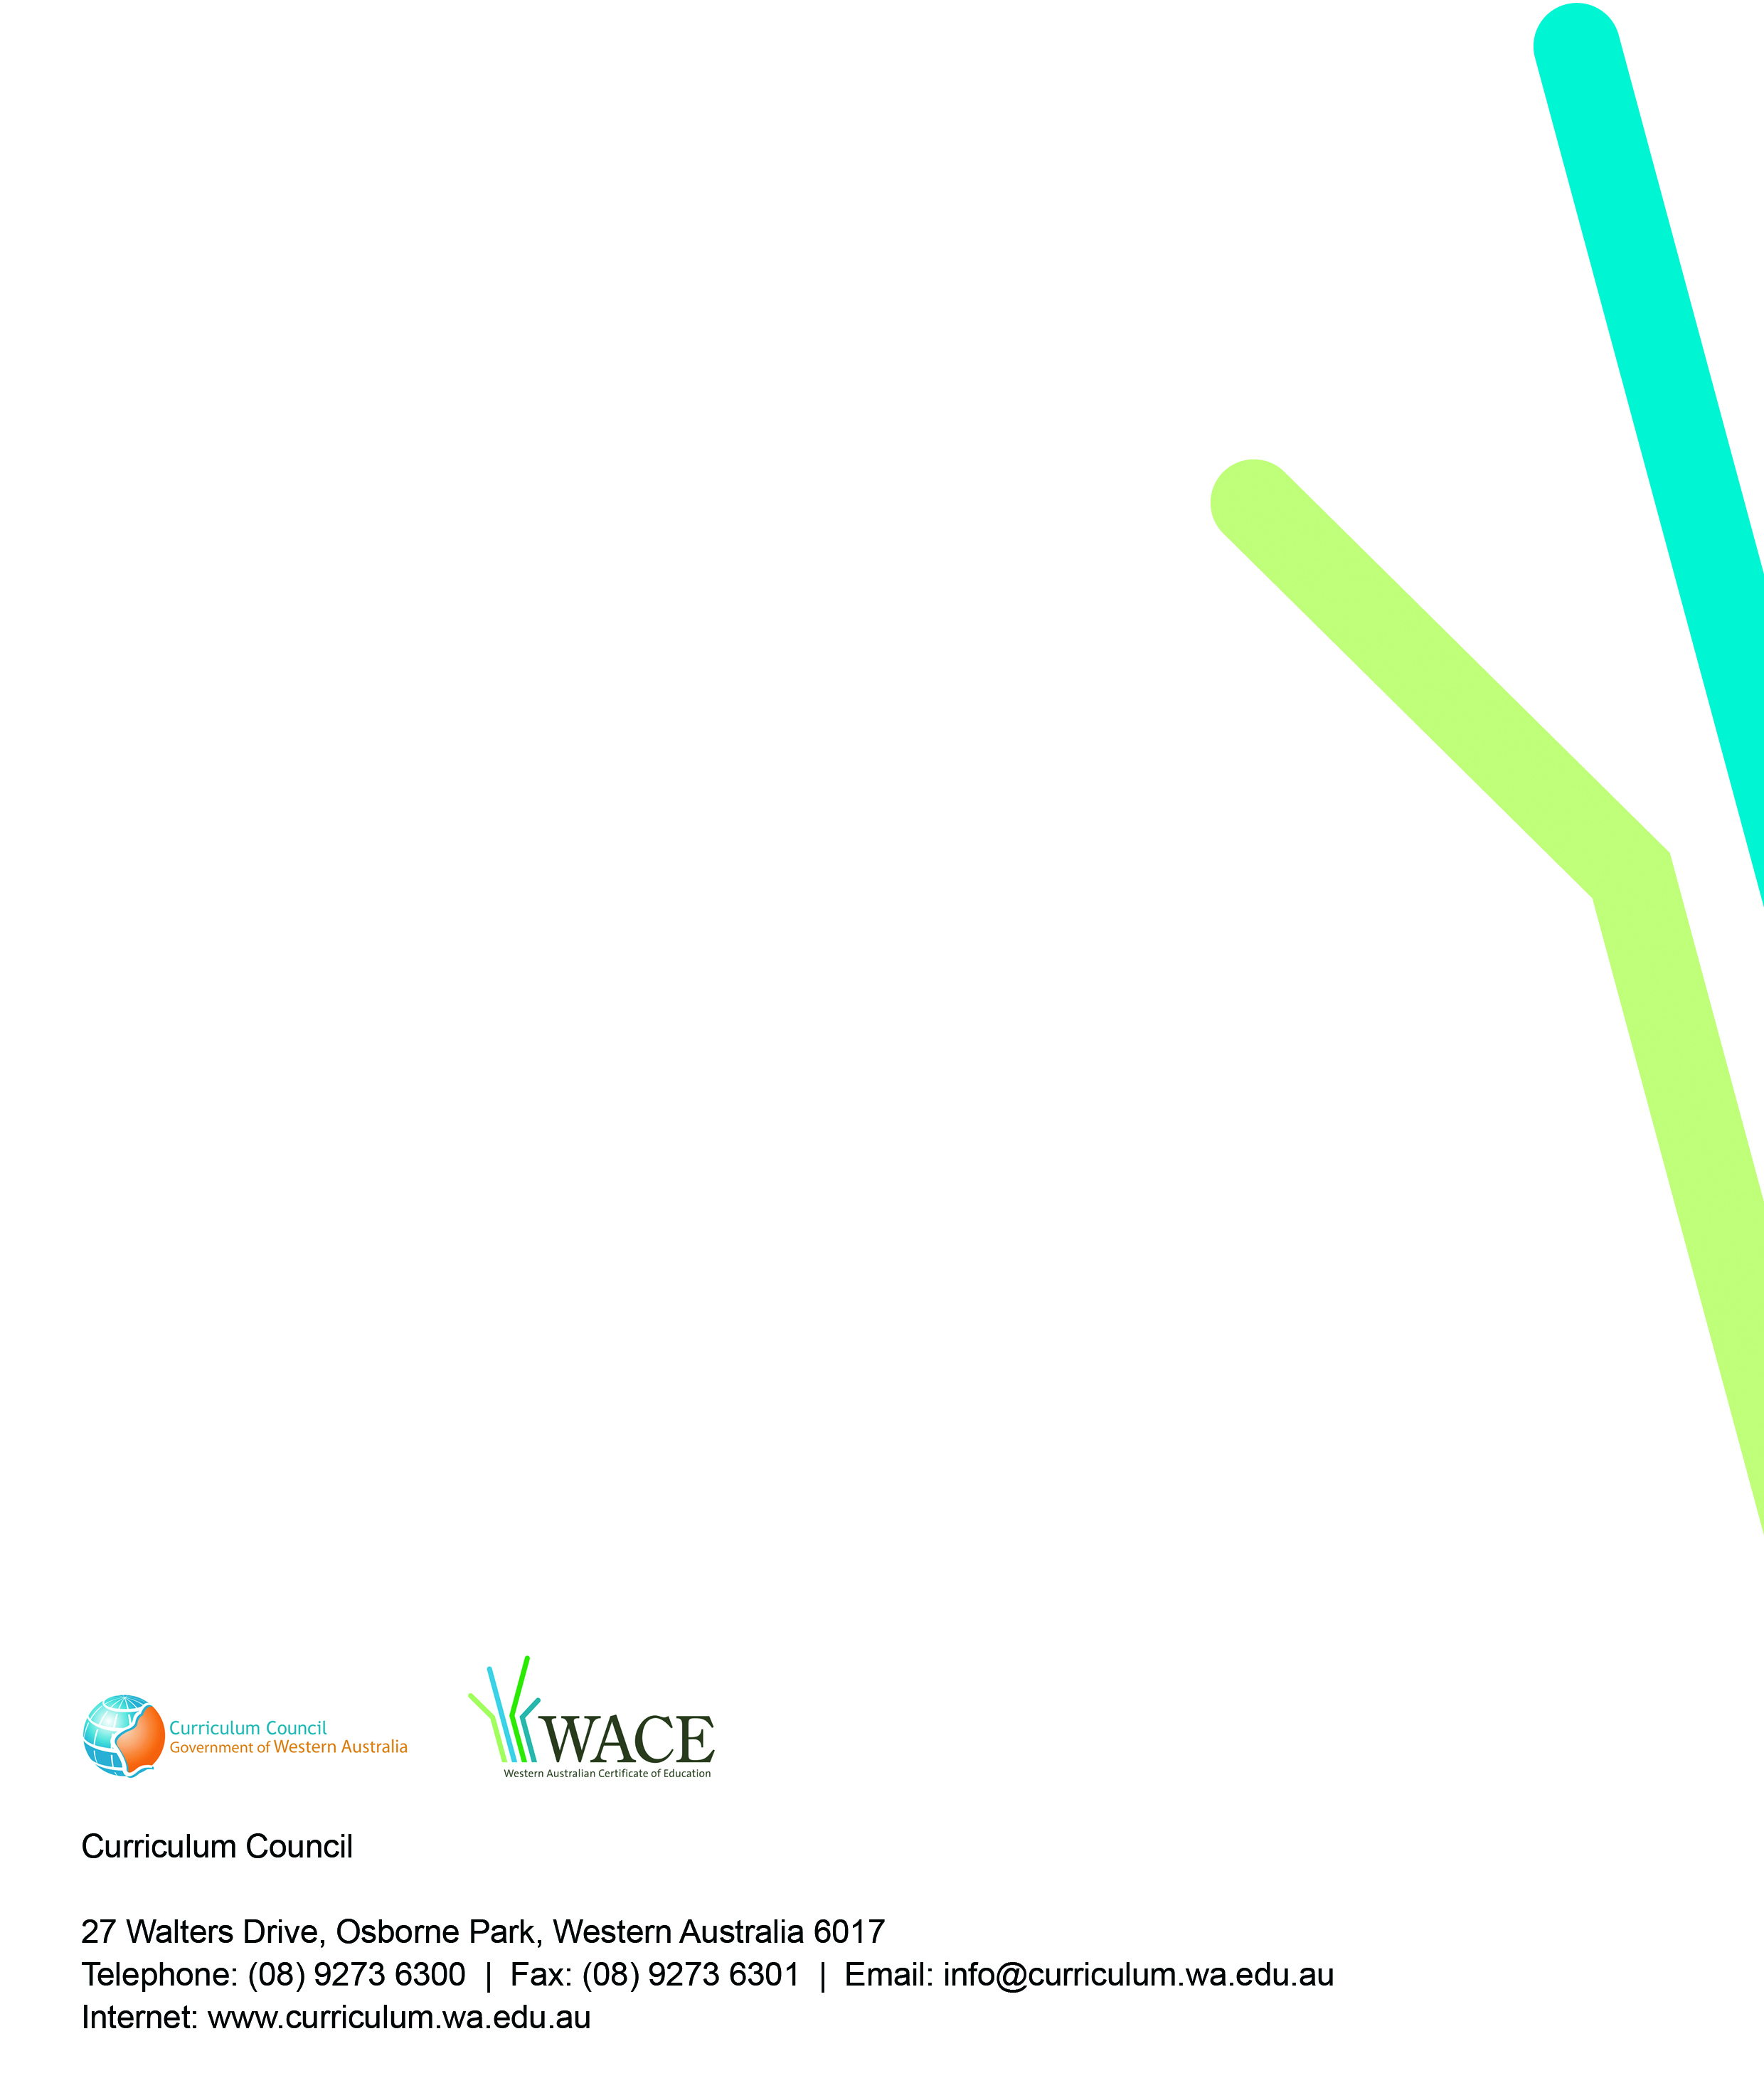
TRIM: 2009/8137[v4]

